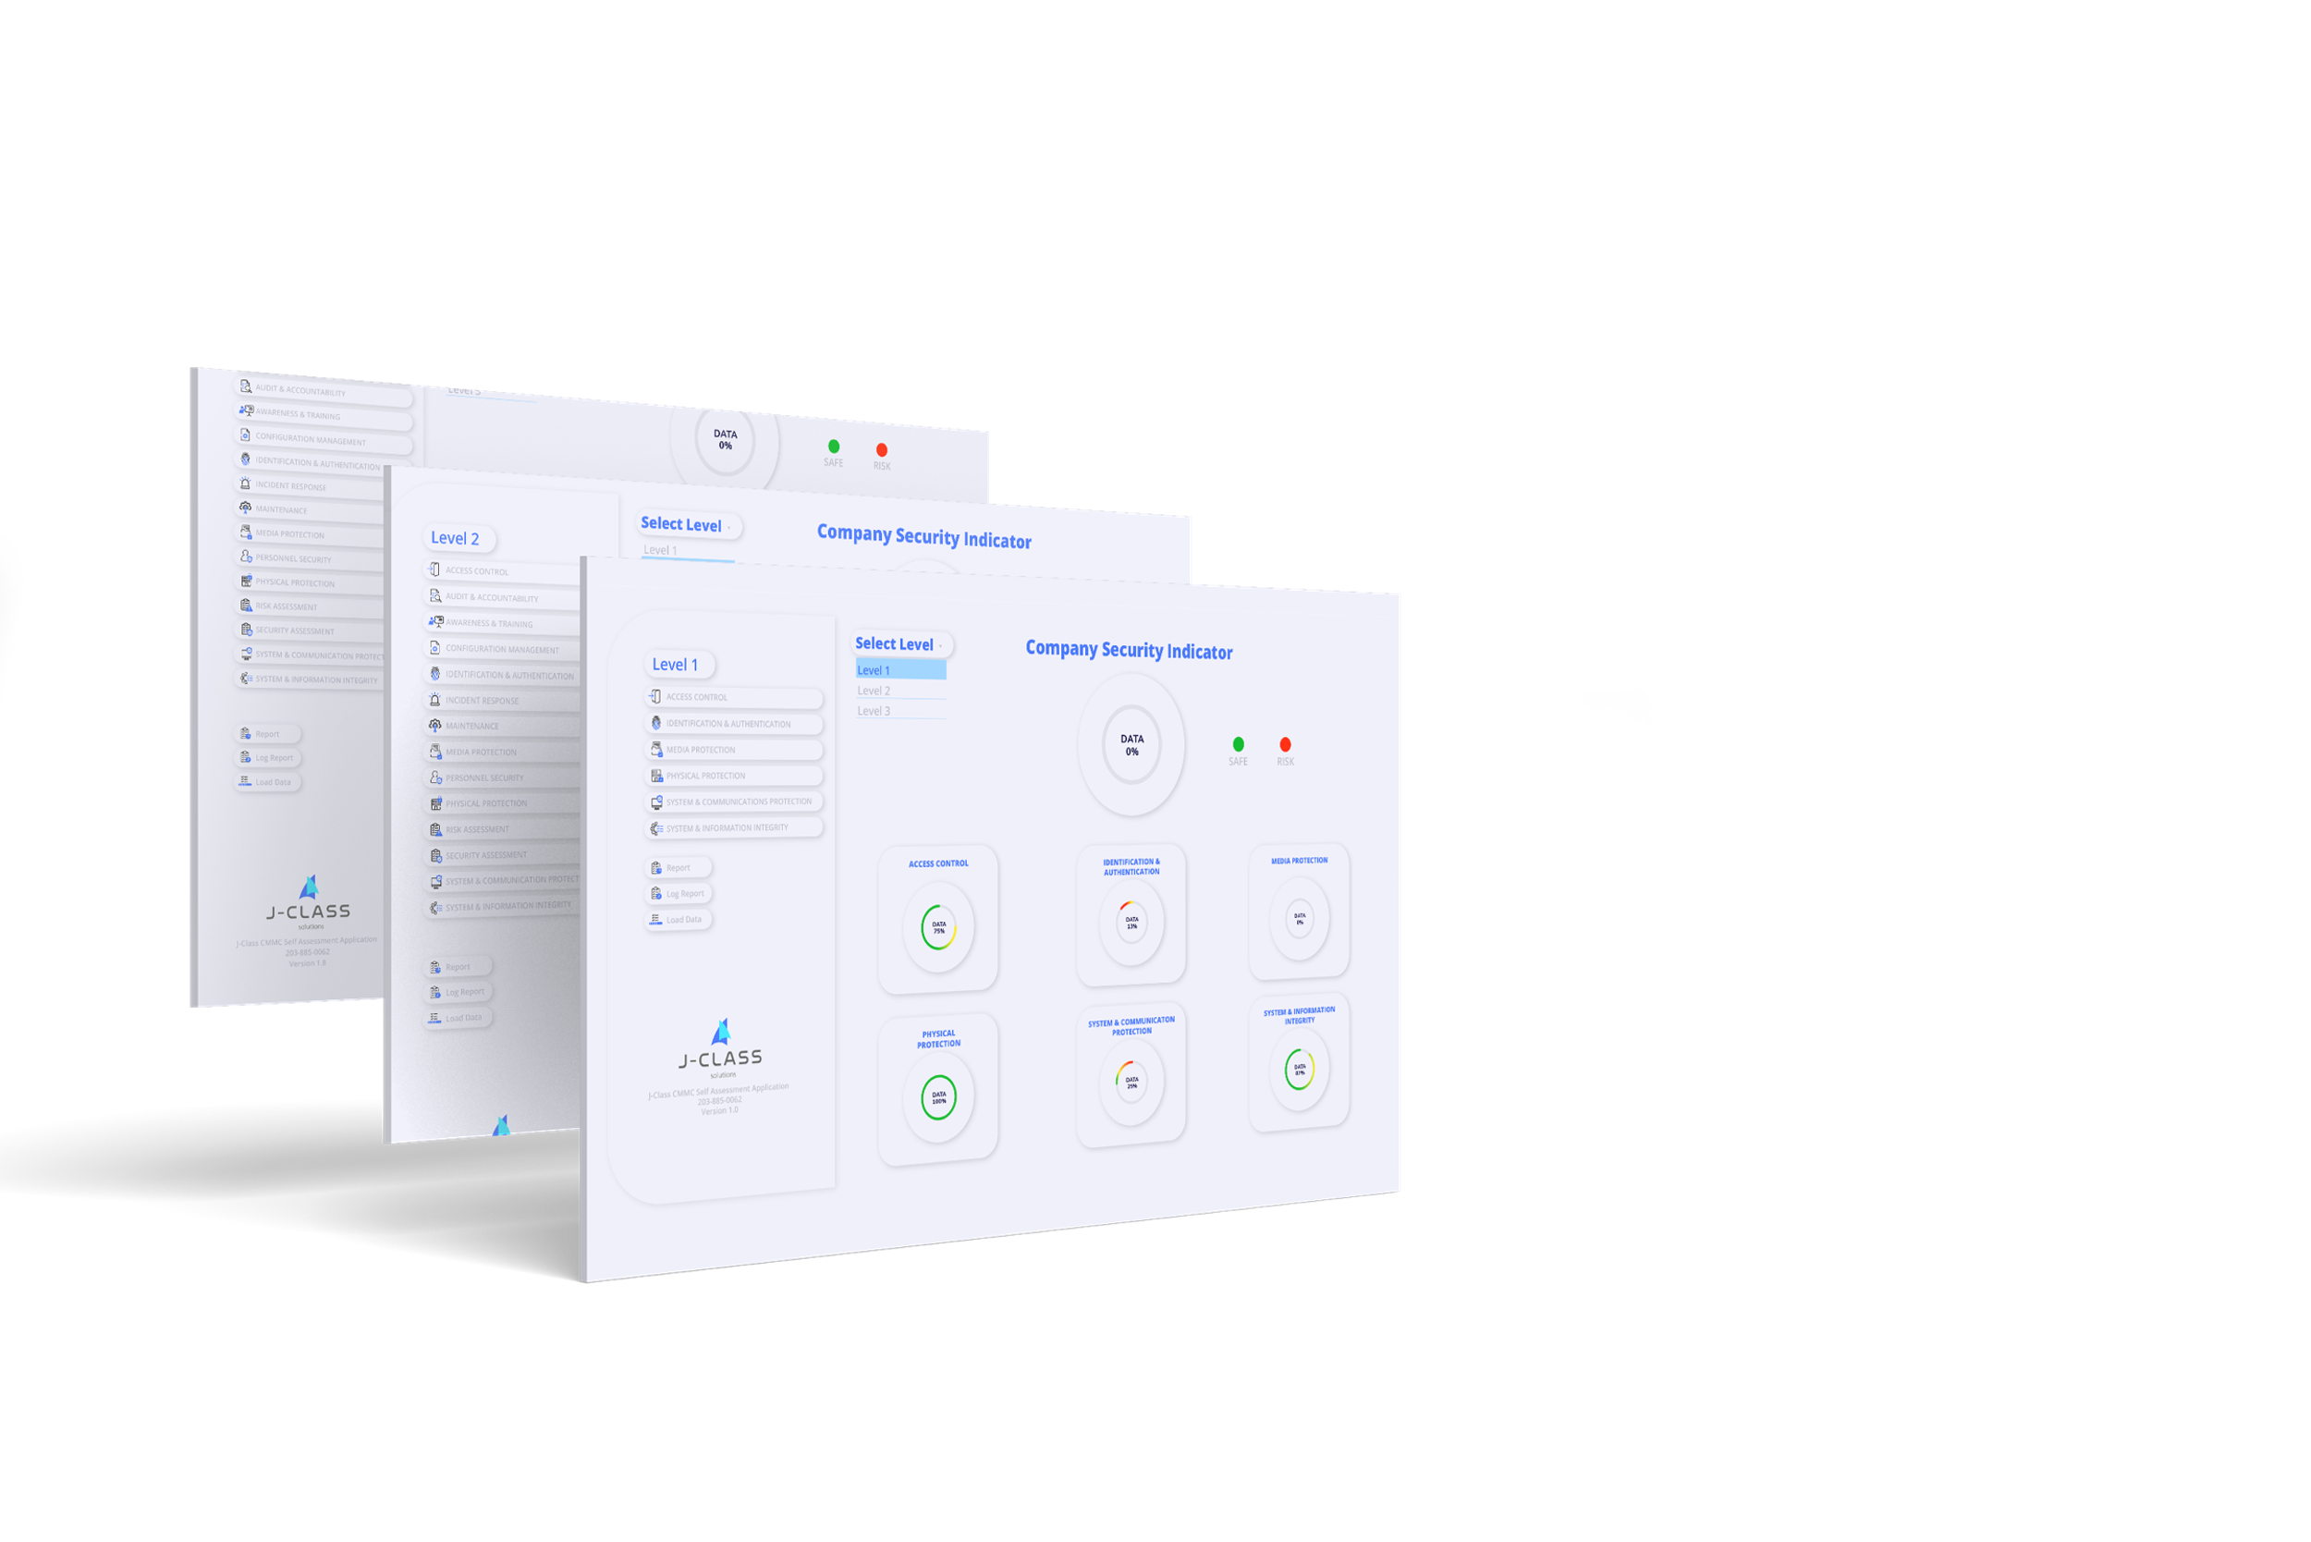
J-Class CMMC Self Assessor Application is the desktop application designed and developed by J-Class Solutions for Cybersecurity Maturity Model Certification compliance assessment for Defense Industrial Base contractors, sub-contractors, individual companies and government institutes.
This user guide document discusses the prerequisites, step by step installation, how to run the self-assessor application and how to use its features.
J-Class CMMC Self Assessor is a desktop application built with Java Swing, JVM dependent and can run on any machine as long as the machine is running JVM.

Prerequisite
Before downloading and running the self assessor application, it is recommended to make sure you have the JRE running on the machine since the application is platform independent. To confirm that your machine has a right JRE/Java run the below command as the self assessor application supports Java 8 or later versions.
java-version
The command gives the output equivalent to the following:
java version "11.0.17" 2022-10-18 LTS
Java(TM) SE Runtime Environment 18.9 (build 11.0.17+10-LTS-269)
Java HotSpot(TM) 64-Bit Server VM 18.9 (build 11.0.17+10-LTS-269, mixed mode)
If the command does not give the output similar to the above, it means that you don't have java installed on your machine/system. Visit here to download java and follow the installer instructions to install. After installation you can run the command again and see if you have the right output.
Note: the application supports Java 8 or later Java versions.

How to get the Assessor
After Installing and checking all prerequisites, now, it’s time to download the Assessor application from J-Class Solutions Website. Purchase the Assessor application and a download link will be automatically sent through the email.

Installing and Running the Assessor
Now we have the assessor application in our desired directory location, navigate to the application container folder location and double click the assessor.jar file to execute the application if you are using the machine with Graphical User Interface (GUI) desktop.
Alternatively, Open the terminal / command Prompt depending on the platform running your machine, change the directory to the directory containing the assessor.jar file then run the following commands:
1. For Windows Machine
cd C:\Users\username\assessor\directory\location
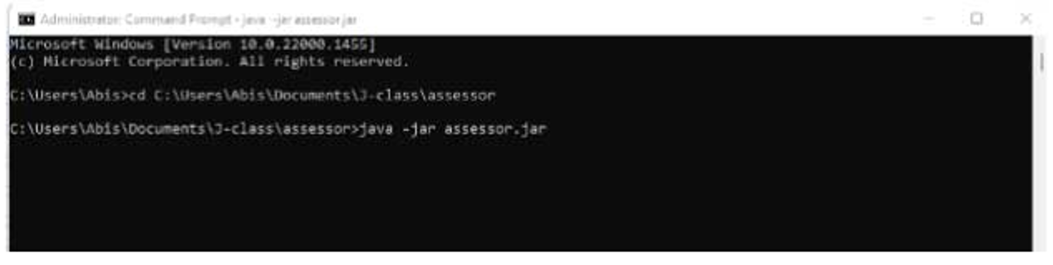
java -jar assessor.jar
After running the command you will see the application starting.
2. For Linux Machine
java -jar assessor.jar
Or make the .jar file e xecutable by running chmod +x assessor.jar and executing using ./assessor.jar command as shown below.
make .jar executable (chmod +x assessor.jar)
./assessor.jar
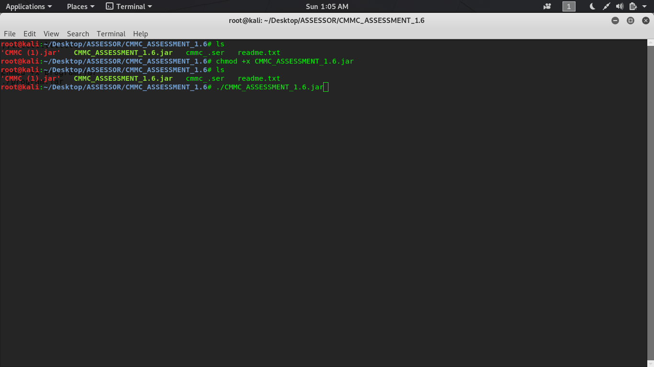

After running the above commands, you will see the screen below showing the application starting to run.

The application loads all required resources and opening the application home page by default shows the dashboard with no data see the screen below.
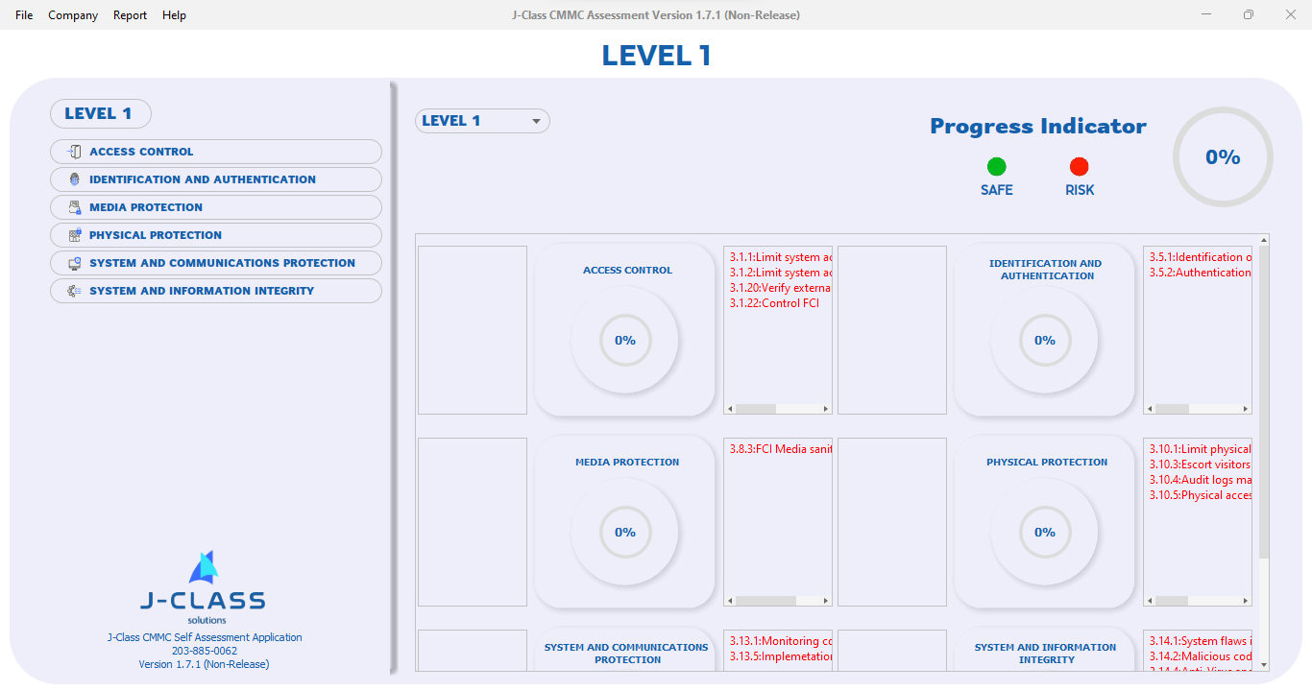

The Assessor Application Dashboard
In the previous section of this guide, we managed to execute the assessor application and open the dashboard as default home page or starting page. In this Dashboard, you will find domains for Level 1, with the option to select a different Level to display its domains. To access the controls, click on a domain name and it will display all the information in it.

Add Data to Assessor Application
Navigate to Level and select level of your choice then on the left navigation select the domain access control click the button, the application opens a new page as the screen below where you can start filling the information.

Process: In this section, provide a summary description of how you have implemented a particular control requirement.
Process Owner: In this section, provide the name and role of the person who has been assigned the control. i.e System Administrator
Technology: In this section, provide the name of the solution/tool/software that is being used to implement a particular control.
Internal Notes: This section is for noting down notes, and ideas for internal use only.
Upload Evidence Screenshot: The screenshot provides evidence of control being implemented
Note: You can repeat the same process to navigate to Identification and Authentication and other domains and fill the data as shown in the screen of this section.

Upload Evidence Screen Image
In the previous section, you navigated to access control and you provided some input data, now in this section upload the evidence screenshot by clicking on the Upload evidence screenshot button, navigate to where the image has been stored on your computer and upload see the screen below.

After uploading an evidence image and you’re sure satisfied with the information provided you can click on the save button to save the data, you will be informed of data saved or not saved, see the screen in this section to understand how it is done.

System Security Plan (SSP)
This refers to a document which describes the information system of an organization. It provide in-depth details about the network, devices connected to the network, solutions in use, clouds in use and the security requirements that have been implemented, planned to be implemented or not implemented.
To generate the SSP navigate to level 2 then click on the Generate SSP button and provide implementation details of each objective question.

After answering the question and all information you need filled click on the button save to save the data, in this page you can print the SSP by clicking the print SSP button see the screen below.

Report
In the report tab, you will find Internal Report, External Report and Log Report. Internal report prints out the information captured in the internal notes section of each control, while the external report prints out the information captured on the process, process owner, technology fields and the evidence screenshot uploaded. Log report captures and shows the changes that have been made in each control’s data fields.

Internal Report
To generate an Internal Report, click on the Report tab and select Internal Report. Choose the level and select the domain(s) that you would like to print the report from and click print report. The screenshot below shows the internal report generation process.

External Report
To generate an External Report, click on the Report tab and select External Report. Choose the level and select the domain(s) that you would like to print the report from and click print report. The screenshot below shows the external report generation process.

Log Report
To generate a Log Report, click on the Report tab and select Log Report. Navigate to the level domain(s) that you would like to print the report from and click print report. The screen below shows the log report generation process.
After the report is generated, it can be printed or saved as a pdf file. Remember that this Log Report contains all information of change when you save and edit data.

Company
In this Company tab, you will fill in the name of the company and its address then click on submit button to save it. Navigate to the Company tab, click on Create/Edit and the screen below shows how to.

After providing the desired details for company and address and submitted, now close the window to proceed.

Loading From File
In the File tab navigate to Load File option or you can use shortcut ctrl + L, navigate and select the .cmmc file. The app loads data from the file and populates to the system as shown in the screen below.

Saving App Data to File
In the File tab, navigate to Save As option or use the shortcut ctrl + shift + S, then the app opens the popup dialog asking to provide the desired file name and you may choose the directory from which the file is going to be stored. Take a look at the below screen.

Removing File Data from the App
In the File tab, navigate to Close File option or use the shortcut ctrl + K, then the linked file data is removed from the app. See the below screen.

Resetting application Data
The assessor application has an option to reset application data. Find this option in the file tab navigate to Reset application data option or use the shortcut ctrl + R and you will be prompted to select reset data options available to remove data from the application. This option is used if and only if you no longer need the data stored in the application database as the action of removing data cannot be undone once confirmed.

After confirming the option to reset, all data is removed from the application and the application restarts with zero data as shown in the screen below.

Exit
The application has an option to close it in case done using the application navigate to File tab then select the Exit option to close the application.

After the exit option selected the application exit until the java -jar assessor.jar command is executed again.

Conclusion
The assessor application can be used in any machine running any operating system as long as the machine can run java 8 or later java versions. It is easy to run, for Windows users just double click on the assessor.jar file then the application starts.

